Create!
Connect!

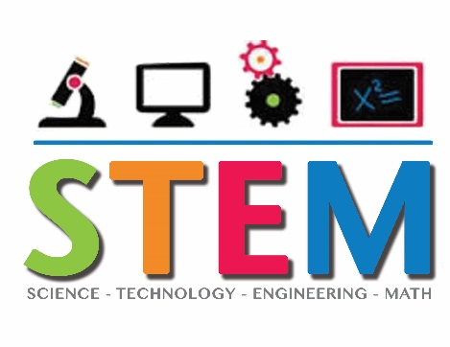
Lots of Fun!
Door Awards
Celebrate!
3rd Trimester STEM Celebration of Learning
We are Celebrating World Creativity and Innovation Week!
When: Monday, April 16
Time: 5:30-7:00 pm
Where: Lake Hills STEM Magnet School
Who is Invited: All K-6 Lake Hills families and
Special Guests
- K-6 students will be performing on stage at 6:30 pm.
- The Lake Hills Parent Group will be providing a free supper (pasta, dinner roll, salad, cookies, lemon-aid)
- Hands-on STEM activities will be provided for families to enjoy.
- STEM projects created by students will be on display.
- An ice-cream sundae party will be given to the class with the most people in attendance.
--------------------------------------------------------------------------------
Please return the bottom of this paper so we know how much food to buy. Only one paper per family is needed. WE HOPE TO SEE YOU ON APRIL 16.

Our family will be bringing _______ people to the STEM Celebration on April 16.
Parent’s Signature _______________________________________

